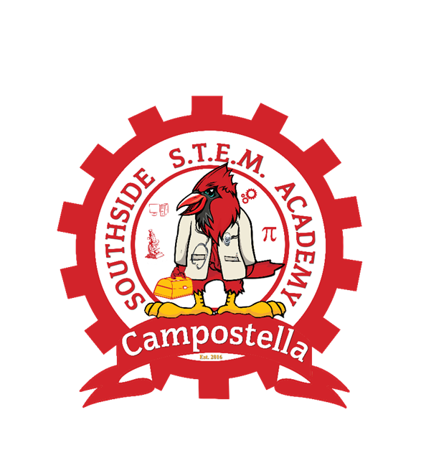

Welcome to an exciting Cardinal year! Please allow me to introduce myself, I am **Ms. La’Shon Jordan**, your new **Family Engagement Specialist**. I am located in The Parent Center across from The Main Office. I am excited to be a part of the Cardinal Family!

I have several exciting and informative virtual and face-to-face workshops planned this year. The workshops will assist parents with the strategies to support the academic needs and success of all students. Academic workshops will be offered twice a month on a variety of topics. The topics will include virtual learning strategies, reading strategies, math, SOL preparation and study skills. Workshops will also include encouraging the emotional growth of students, examining different learning styles, and the connection of social-emotional learning to student success. The information for the workshops will be listed here on our school’s website.

**Looking to volunteer at Southside STEM Academy @ Campostella?** The link to register is listed on the Norfolk Public Schools website. Please be sure to select Southside STEM Academy @ Campostella as your site.

Do you need resources to help your Cardinal with his/her homework? The Family Engagement Specialist is your contact for any resources that you may need.

Please let me know if I can be of assistance to you. I can be contacted by email at [**ljordan616@nps.k12.va.us**](mailto:ljordan616@nps.k12.va.us)or by phone, my direct line is (757) 494-3850 ext. 3195.

Let’s have a great school year!

“Teamwork Makes the Dream Work”

Ms. La’Shon Jordan your Family Engagement Specialist